Chapter 1 Notes

Numbers and Measurement
I. Numbers- there are two types.
exact numbers (known as counting or defined). A dozen is always 12 and is an exact number.
inexact numbers (derived from measurement).

II. Measurement- must have a number and a unit.
a. All units will be SI (metric).
Mass = kilogram
Length = meter
Time = second
Temperature = Kelvin
Volume = Liter
b. Must be able to convert from one metric unit to another

Prefix | Symbol | Meaning | Scientific Notation
Base (meter, liter, gram) | ---------------------- | 1 | 1 X 10⁰
kilo | k | 1000 | 1 X 10³
centi | c | .01 | 1 X 10⁻²
milli | m | .001 | 1 X 10⁻³
micro | μ | .000001 | 1 X 10⁻⁶
nano | n | .000000001 | 1 X 10⁻⁹

c. Temperature
K = ºC + 273 ºC = K - 273

III. Significant Figures
Rules for Counting Significant Figures

1. Nonzero integers are always significant.
Example: 243 3 sig. figs.
5,479 4 sig. figs.
1.9432 5 sig. figs.

2. Zeros
a) Leading zeros are never significant.
Example: 0.0034 2 sig. figs.

b) Captive zeros are always significant.
Example: 306 3 sig. figs.
4,008 4 sig. figs.

c) Trailing zeros are significant if the number contains a decimal point.
Example: 100.0 4 sig. figs.
100 1 sig. figs.
0.002540 4 sig. figs.

3. Rules for Significant Figures in Mathematical Operations

a) Multiplication or Division
The number of sig. figs. in the answer is the same as the number in the least precise
measurement used in the calculation. Round your answer to the least number of
sig. figs. in the problem. For example: 435.6 X 1.23 = 535.788 = 536 (3 sig. figs.)
. b) Addition or Subtraction
The answer has the same number of decimal places as the least precise measurement
used in the calculation. Round your answer to the least number of decimal places
in the problem. For example: 235.6247
+ 1.2
236.8247 = 236.8 (1 decimal place)

4. Exact numbers don’t affect the number of sig figs an answer should have.

IV. Scientific Notation- It is a short hand method for writing very large and very small numbers.
a) Numbers in scientific notation are made up of three parts:
the coefficient, the base and the exponent. Observe the example below:
5.67 x 10⁵
This is the scientific notation for the standard number, 567 000. Now look at the number
again, with the three parts labeled.
5.67 x 10⁵
coefficient base exponent
b) In order for a number to be in correct scientific notation, the following conditions must be true:
1. The coefficient must be greater than or equal to 1 and less than 10.
2. The base must be 10.
3. The exponent must show the number of decimal places that the decimal needs to be moved to change the number to standard notation.
a. move decimal left – exponent POSITIVE
b. move decimal right– exponent NEGATIVE

V. Rounding Rules
**Each example is rounded to three sig digs.
1. If the digit to the immediate right of the last sig fig is < 5, do not change the last sig fig.
Example 2.532 → 2.53

2. If the digit to the immediate right of the last sig fig is ≥ 5, round up the last sig
fig.
Example 2.536 → 2.54

VI. Dimensional Analysis-Conversion Factor
A. Start with the original number and unit
B. Multiply by a unit factor with the unit to be discarded on the bottom and the desired unit on top.
C. Cancel units.
D. Perform numerical calculations.
20 kg X 1000g X 1000 mg = 20,000,000 mg
1 kg 1 g
E. A pencil is 7.00 in. long. What is its length in centimeters? ( 1inch =2.54 cm)

7.00 in X 2.54cm = 17.8 cm
1 in

VII. Precision and Accuracy
accuracy – correctness; agreement of a measurement with the true value
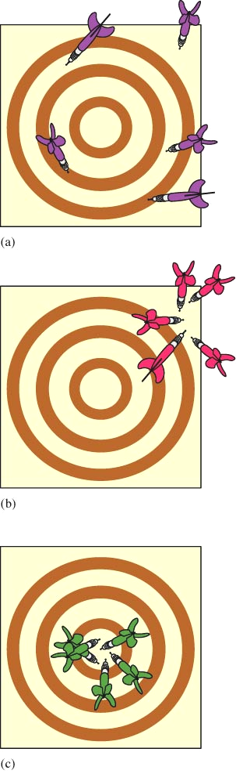
precision – reproducibility; degree of agreement among several measurements.
random or indeterminate error – equal probability of a measurement being high or low
systematic or determinate error – occurs in the same direction each time
percent error- determines the deviation of a measurement from the true value.
% error = experimental value – true value X 100%
True value
The results of several dart throws show the difference between precise and accurate. (a) Neither accurate nor
precise (large random errors). (b) Precise but not accurate (small random errors, large systematic error). (c) Bull’s-eye! Both precise and accurate (small random errors, no systematic error).

VIII. Density
ratio of mass to volume
high density: a lot of mass in a small area
physical property of a substance
Density = mass = m
volume v

IX. States of Matter
Solids, liquids, and gases are the three forms of matter called the states of matter.
Properties described on the macroscopic level:
• gas (vapor): no fixed volume or shape, conforms to shape of container, compressible.
• liquid: volume independent of container, no fixed shape, incompressible.
• solid: volume and shape independent of container, rigid, incompressible.
Properties described on the molecular level:
• gas: molecules far apart, move at high speeds, collide often.
• liquid: molecules closer than gas, move rapidly but can slide over each other.
• solid: molecules packed closely in definite arrangements.

X. Classification of Matter
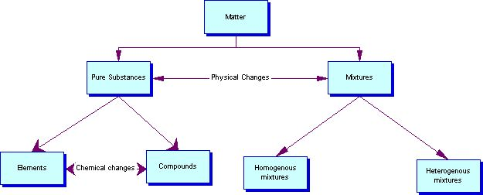
Substances-
a. Cannot be separated into different parts by physical means, only chemical means
b. Two types of substances
Elements
i. A substances with only one type of atom
ii. Cannot be divided or changed
Compounds
i. Substance formed from two or more atoms bonded together.
ii. Example: Water (H₂O), Salt (NaCl)
Mixtures
a. Can be separated by Physical Means
b. Two types of mixtures

Homogeneous-
i. Composition and appearance is the same throughout.
ii. Mostly solutions
iii. Examples: Coca-Cola, Chocolate Ice Cream, Sugar Water
Heterogeneous-
i. Mixture with visibly different composition, appearance or phases.
ii. Different samples are made of different things
iii. Mostly suspensions
iv. Chicken Noodle soup, Italian Salad Dressing, Muddy Water

XI. Physical Separation Techniques

i. manual separation – sorting

ii. magnetism-sorting by attraction of certain metals to a magnet.

iii. sifting-using size differences to separate particles.

iv. filtration-passing a cloudy liquid through a filter to retain the solid and let the liquid pass.

v. centrifuging-using centrifugal force to pack solid particles to the bottom of a tube.

vi. decanting-pouring off the liquid from the top and retaining the solid on the bottom.

vii. evaporation-changing the liquid to a gas using heat, while retaining the solid.

viii. distillation-based on differences in boiling points, two liquids can be separated when one changes to a gas and the other remains liquid.
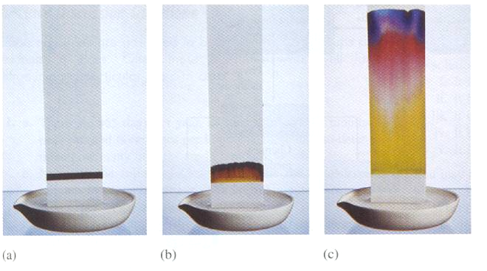
ix. chromatography-
(a) A line of the mixture to be separated
is placed at one end of a sheet of porous paper.

(b) The paper acts as a wick to draw up the liquid.

(c) The component with the weakest
attraction for the paper travels faster than those that cling to the paper.

